**Florida’s Catholic School Promise**

**Enrollment grows in the Sunshine State, thanks to school choice.**

By  The WSJ Editorial Board Follow Aug. 22, 2023 9:46 am ET https://www.wsj.com/articles/florida-catholic-school-enrollment-school-choice-1f25443b?mod=Searchresults_pos1&page=1

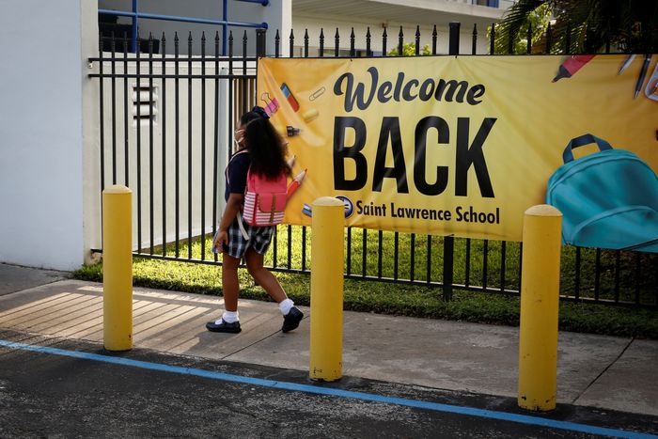St. Lawrence Catholic School in North Miami Beach. PHOTO: MARCO BELLO/REUTERS

One goal of robust school choice programs is to broaden quality education alternatives. A new report brings evidence that this is happening in Florida, where Catholic PreK-12 schools are defying national trends.

Of the 10 states with the highest Catholic school enrollment, Florida is the only one where Catholic school enrollment has grown over the past decade. It’s a modest 4.4%, or 3,644 students, but compare that to New York and New Jersey, where enrollment dropped by more than 30%. Pennsylvania saw a 25% loss. The report comes from Step Up for Students, a nonprofit that administers Florida’s K-12 scholarships.

The Sunshine State’s population growth may have something to do with it, the report acknowledges. But other states showed larger declines in Catholic school enrollment than in the number of school-age children, so other factors seem to be at play. A big one is the state’s private school scholarships.

Florida has offered publicly funded scholarships since 2001 and has expanded eligibility over the years. “As a share of total enrollment, the percentage of choice scholarship students in Florida Catholic schools has risen from 16.3 percent to 46.6 percent” from 2012-13 to 2022-23, says the report.

This year the Legislature passed a bill to open the scholarships to all students regardless of income, so this percentage will likely grow as parents take advantage of the program to afford tuition at Catholic school.

Vouchers encourage education supply as well as demand, and private schools have multiplied. The number of private and charter schools grew by about a third in the decade through 2021-22, which means more competition for Catholic schools.

Moral education is a traditional attraction of Catholic school for many parents. But the report notes that “in order to stand out on a landscape where parents have more choices every day, many Catholic schools here are offering distinctive programming on top of the core features that have always made Catholic schools attractive and effective.” Several schools now offer International Baccalaureate programs and other specialized courses.

The report highlights two examples of students in remote areas benefiting from Catholic education. Hope Rural School in the Diocese of Palm Beach serves mostly students of agricultural workers. The Diocese of St. Augustine set up a transportation initiative to help students who live in areas that lack Catholic schools nearby. “Examples like these counter widespread myths that school choice ‘can’t work’ in rural areas,” says the report.

Separately, a recent report from Teach Coalition found that Jewish kindergarten enrollment in Florida grew by more than 45% from 2016 to 2021, while declining in New York, which has a large Jewish population.

Advertisement - Scroll to Continue

All of this is a good signal that Florida’s steady school choice expansion has helped students and families. Other states can encourage similar growth and competition by expanding vouchers and scholarships for all children.